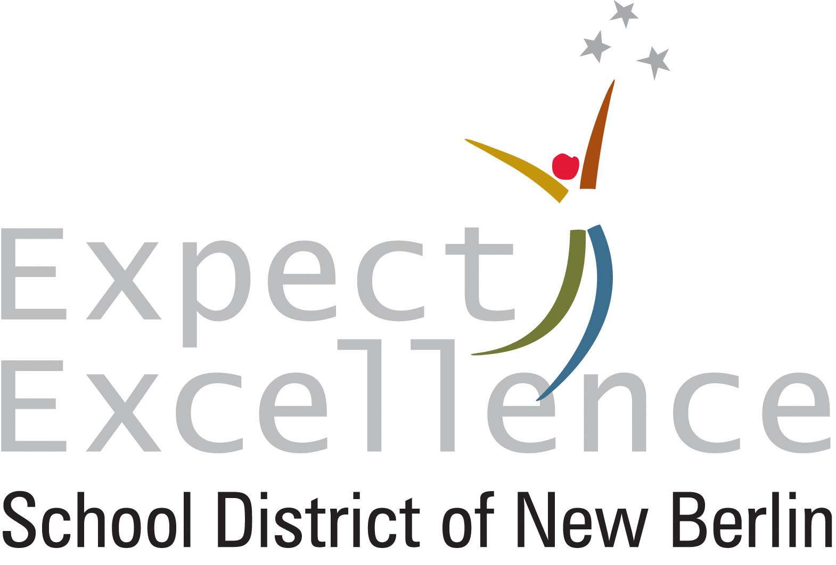

For Immediate Release  
Date: 11/19/24  
Contact: David Cotey, Director of Communications

262-789-6225 | david.cotey@nbexcellence.org

**School District of New Berlin Maintains Highest Level of Achievement on State Report Cards**

New Berlin, Wis. – For the eighth consecutive year in which report cards were issued, the School District of New Berlin “significantly exceeds expectations”, according to 2023-24 state-issued district report cards released today. Of the 377 districts statewide, the SDNB is one of just 15 to reach that level, and one of only 10 K-12 districts to do so.

|  |  |
| --- | --- |
|  | 2023-24 Score |
| District | 83.5 |
| Elmwood | 89.8 |
| Orchard Lane | 84.6 |
| Poplar Creek | 91.8 |
| Ronald Reagan | 79.5 |
| Eisenhower | 83.6 |
| West | 81.8 |

Additionally, all six of the SDNB schools once again either “exceed” or “significantly exceed” expectations on the Wisconsin Department of Public Instruction’s school report cards. Elmwood Elementary, Orchard Lane Elementary, Poplar Creek Elementary and Eisenhower Middle / High “significantly exceed expectations”. Ronald Reagan Elementary and West Middle / High “exceed expectations”.

District and school report cards are intended to offer accountability of how well schools and districts statewide are preparing students to graduate.

Of the nearly 1,075 public elementary schools in the state, Poplar Creek (91.8) is one of fewer than 50 to achieve a 90 or better. Also, Eisenhower, is one of only 18 public high schools overall and one of just 12 traditional (non-preparatory, non-charter, etc.) public high schools to “significantly exceed expectations”.

“It takes an incredible amount of dedication and effort from everyone in our organization to achieve and sustain the level of excellence we have for the better part of a decade, especially as it relates to the state’s report cards,” Superintendent Joe Garza said. “This is one of several ways in which we measure ourselves up to the best districts in the state and we’re proud that we continue to be among them.”

Report cards provide an accountability index score from 0-100 based on performance in four priority areas:

* **Student achievement**, or how well the students performed on state assessments using a points-based proficiency system with the score a result of a multi-year average of English language arts and mathematics subscores;
* **Growth**, or year-to-year student progress on statewide tests;
* **Target Group Outcomes**, which examines outcomes for students with the lowest test scores and is designed to promote equity by helping districts focus on learners who need the most support while also improving outcomes for all students;
* **On-track to graduation**, or how successfully students are progressing toward completing their K-12 education.

All four of the SDNB’s district priority area scores were the same or higher than at least 94.7 percent of all districts in the state.

Over the summer, the DPI changed the cut scores on statewide standardized assessments. As a result, the DPI implemented a one-year scale adjustment to the report card’s achievement scoring to allow for better comparability of report cards.

All SDNB report cards can be viewed at [www.nbexcellence.org/district/school-report-cards.cfm](http://www.nbexcellence.org/district/school-report-cards.cfm).

**Please note:** The SDNB has unique grade-level structures (elementary grades K-6, secondary grades 7-12) that should be taken into consideration when community members, media and others compare scores and ratings to other districts and schools.

###